Algebra 1: Unit 13, Lesson 6

- The graphs of $y=x^{3}$ and $y=x^{3}+2$ are shown on the coordinate grid.
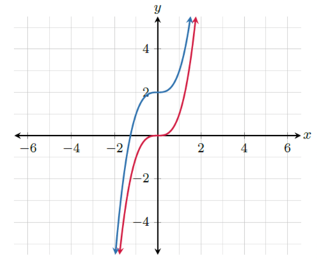
What is the shift from $y=x^{3}$ to $y=x^{3}+2$?
Vertical shift up 2 units

- Write a function that describes a horizontal shift $3$ units left of $f(x).$
$$f(x)=(x+3)$$

- A table of values for functions, $f(x)=x^{2}$ and $g\left(x\right)=x^{2}-3$, is shown.
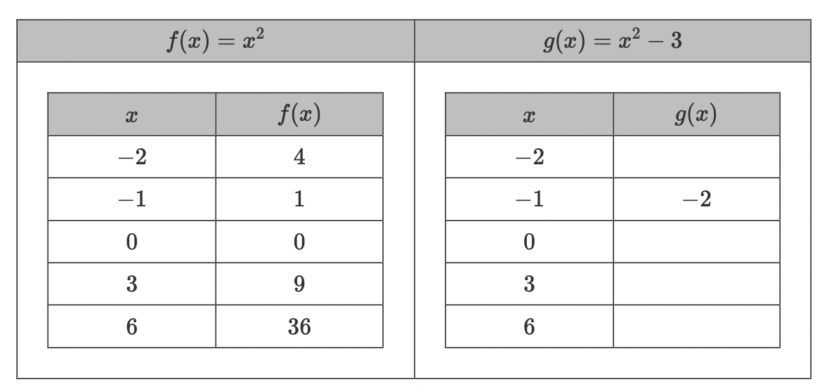
What is the missing $y$-value for the coordinate point of $g(3)$?
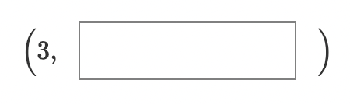
$$6$$

